**##URLs**

[**https://www.elprocus.com/mosfet-as-a-switch-circuit-diagram-free-circuits/**](https://www.elprocus.com/mosfet-as-a-switch-circuit-diagram-free-circuits/)

**AC and DC Currents.**

In direct **current** (DC), the electric charge (**current**) only flows in one direction. Electric charge in **alternating current** (**AC**), on the other hand, changes direction periodically. The voltage in **AC** circuits also periodically reverses because the **current** changes direction.

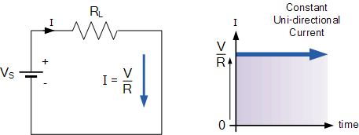

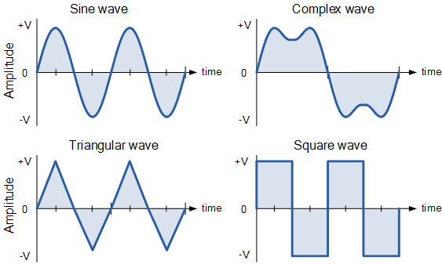

**Resistance**is the **opposition**of **electrical current flow in DC circuits and AC circuits.**

**Impedance**can therefore be thought of as the **opposition of electrical current flow** in a **AC** circuit.

 Combination of Reactance & Resistance is called **Impedance.**

Impedance is also measured in Ohms.

R is the resistance, measured in Ohms (Ω).

I is the current, measured in Amperes (A).

V is the voltage, measured in Volts (V).

A **rectifier** is an electrical device that [converts](https://en.wikipedia.org/wiki/Electric_power_conversion) [alternating current](https://en.wikipedia.org/wiki/Alternating_current) (AC), which periodically reverses direction, to [direct current](https://en.wikipedia.org/wiki/Direct_current) (DC), which flows in only one direction. The process is known as *rectification*, since it "straightens" the direction of current.

Resistors are electronic components which have a specific, never-changing [electrical resistance](https://learn.sparkfun.com/voltage-current-resistance-and-ohms-law/resistance). The resistor’s resistance **limits the flow of electrons** through a circuit.

They are **passive** components, meaning they only consume power (and can’t generate it). Resistors are usually added to circuits where they complement **active** components like op-amps, microcontrollers, and other [integrated circuits](https://learn.sparkfun.com/tutorials/integrated-circuits). Commonly resistors are used to limit current, [divide voltages](https://learn.sparkfun.com/tutorials/voltage-dividers), and [pull-up I/O lines](https://learn.sparkfun.com/tutorials/pull-up-resistors).

The electrical resistance of a resistor is measured in **ohms**.

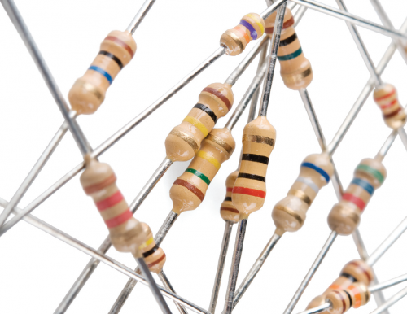

Capacitor.

The capacitor is a component which has the ability or “capacity” to store energy in the form of an electrical charge producing a potential difference (Static Voltage) across its plates, much like a small rechargeable battery.

Also, because capacitors store the energy of the electrons in the form of an electrical charge on the plates the larger the plates and/or smaller their separation the greater will be the charge that the capacitor holds for any given voltage across its plates. In other words, larger plates, smaller distance, more capacitance. Measured in Farads.  1μF, 1nF,  1pF

Q = C x V

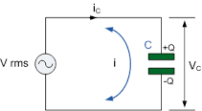

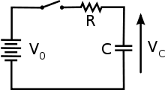





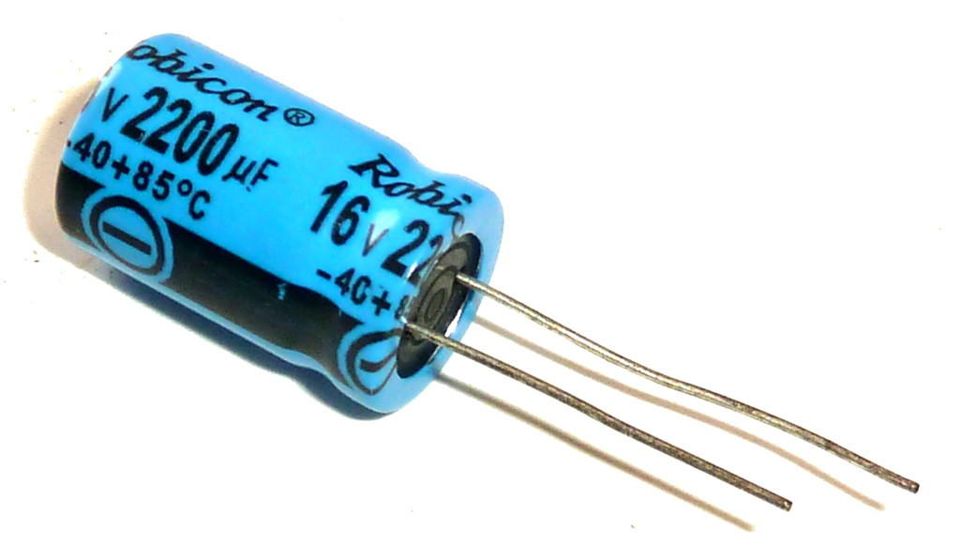

**Inductor.**

An Inductor is a passive device that stores energy in its Magnetic Field and returns energy to the circuit whenever required. An Inductor is formed by a cylindrical Core with many Turns of conducting wire. Figure 1 and Figure 2 are the basic structure and the schematic symbol of the Inductor.

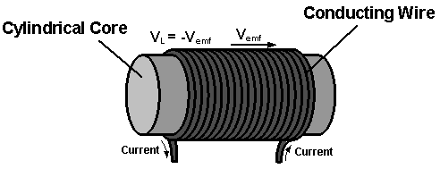

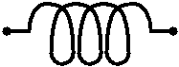

The main difference between a capacitor & inductor is that an inductor is used to store the energy in the form of magnetic field, whereas a capacitor stores the energy in the form of an electric field.

The current creates a magnetic field and due to this magnetic field, electric current is stored for a short interval of time. The electric current drops when the magnetic field around the coil collapses.

**MOSFET BASICS:**

Working Principle of Diode:

N-side will have a significant number of electrons, and very few holes (due to thermal excitation) whereas the p side will have a high concentration of holes and very few electrons. Due to this, a process called diffusion takes place. In this process free electrons from n side will diffuse (spread) into the p side and recombine with holes present there, leaving positive immobile (not moveable) ions in n side and creating negative immobile ions in p side of the diode.

Hence, there will be uncovered positive donor ions in n-type side near the junction edge. Similarly, there will be uncovered negative acceptor ions in p-type side near the junction edge. Due to this, numbers of positive ions and negative ions will accumulate on n-side and p-side respectively. This region so formed is called as depletion region due to the “depletion” of free carriers in the region. Due to the presence of these positive and negative ions a [static electric field](https://www.electrical4u.com/static-electric-field/) called as barrier potential is created across the pn junction of the diode. It is called as "barrier potential" because it acts as a barrier and opposes the further migration of holes and electrons across the junction.

### Forward Biased Diode

In a PN junction diode when the forward voltage is applied i.e. positive terminal of a source is connected to the p-type side, and the negative terminal of the source is connected to the n-type side, the diode is said to be in forward biased condition. We know that there is a barrier potential across the junction. This barrier potential is directed in the opposite of the forward applied voltage. So a diode can only allow current to flow in the forward direction when forward applied voltage is more than barrier potential of the junction. This voltage is called forward biased voltage. For silicon diode, it is 0.7 volts. For germanium diode, it is 0.3 volts.

Diode blocks current in reverse direction. Unidirectional flow of current. Diode acts as a valve in electronic circuits. Forward Biased circuit will be short, In reverse the circuit will be open.

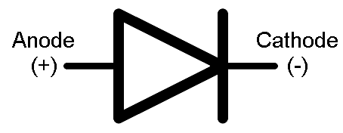

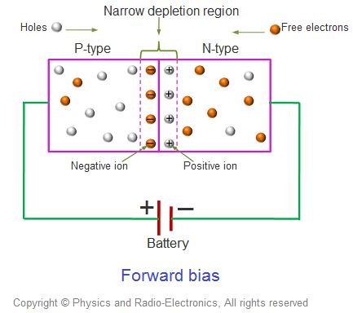

**+**

**++++++**

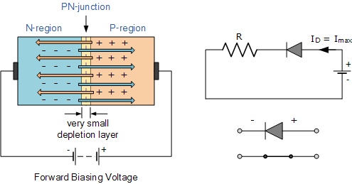

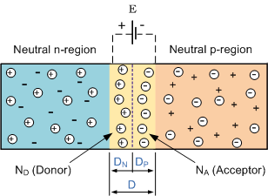

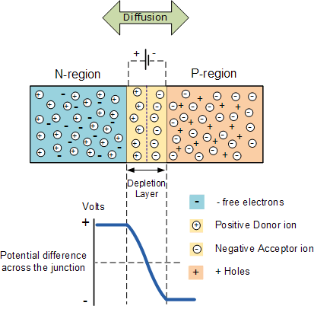

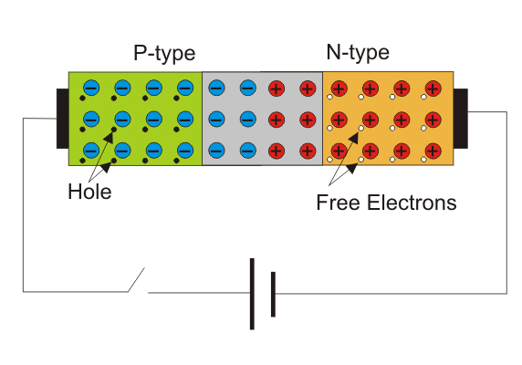

**MOSFET TRANSISTORS.**

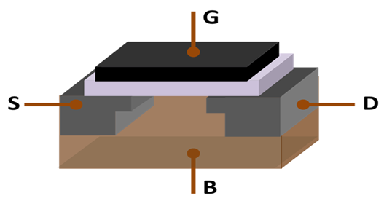

Sio2 insulator.

**Two types of transistors.**

**MOSFET -> Metal Oxide Semiconductors Field Effect Transistors.**

**NMOS, PMOS**

**NMOS = NPN channel.**

**PMOS = PNP channel.**

**NMOS and PMOS are 3 terminal devices. SOURCE, DRAIN, GATE, BODY**

**VGS = VG -VS = 5V = NMOS is on. Since +ve ions try to attract the electrons towards the channel, the channel will get formed with the flow of electrons from source to drain.**

**VGS = VG -VS = 0V = NMOS is off.**

**Since -ve ions could’nt attract electrons towards the channel, Hence there is no flow of electrons from source to drain.**

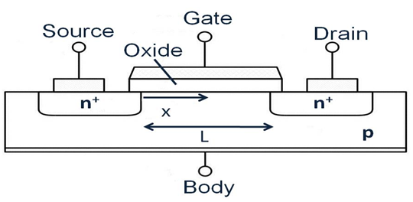

**WHEN NMOS CONDUCTS WITH POSITIVE VOLTAGE.**

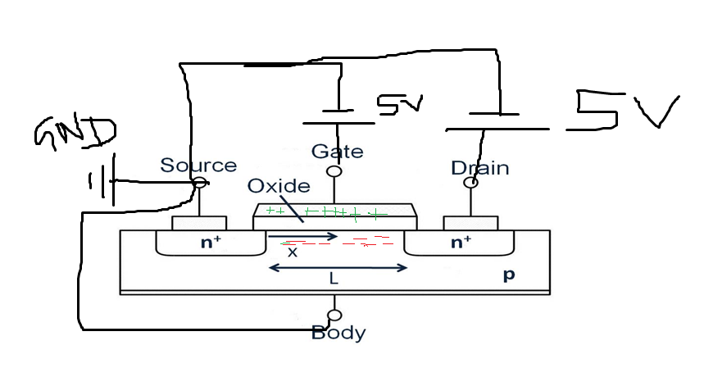

**WHEN NMOS DOES NOT CONDUCTS WITH ZERO or NEGATIVE VOLTAGE.**

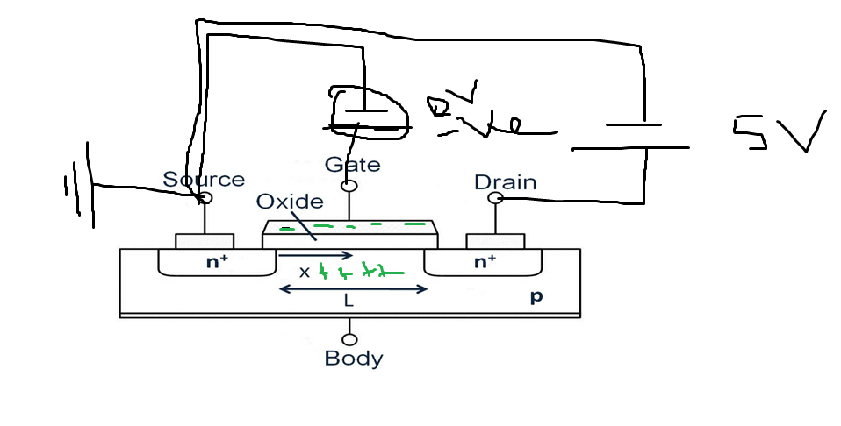

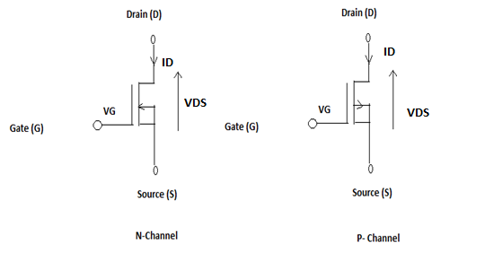



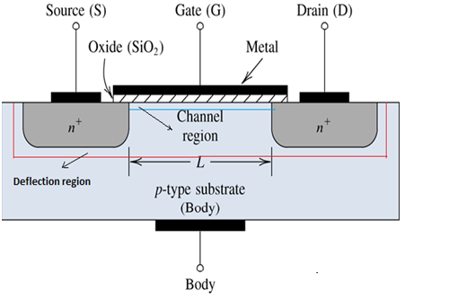

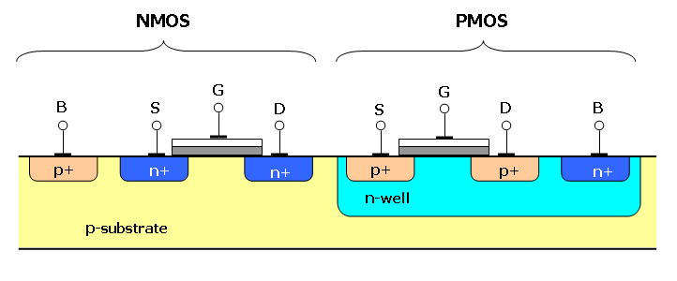

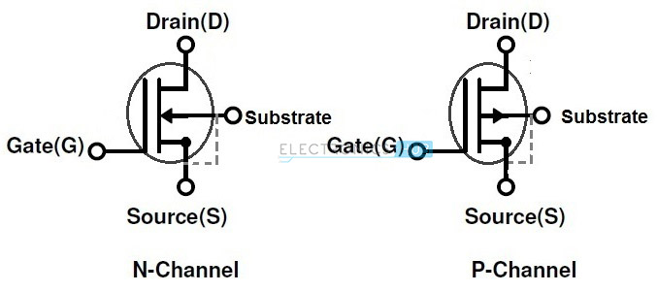

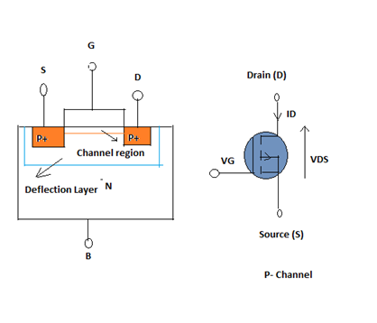



**Enhancement Mode**

